Creating Database in Your Server

You need a Hostinger account or you can also use your local wamp or xampp server. I am using hostinger for the demonstration purpose because it is absolutely free. You can also go to hostinger and signup for a free hosting account.

* Signup for **hostinger https://www.hostinger.es/**
* Order a free hosting account (mine is simplifiedcoding.16mb.com) with a free subdomain
* Open your hosting account
* Espere correo de confirmacion
* Click a Inicio o Home
* From the left menu click on databases
* Create a database

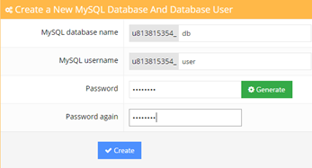

**Creating Database**

* After creating you will see your database below

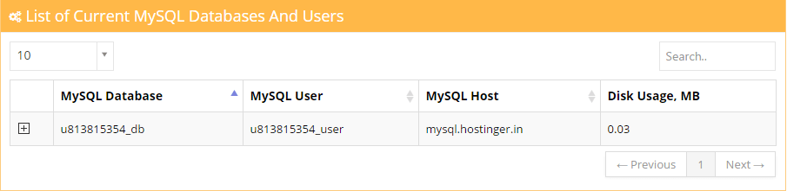

**MySQL Database**

* Copy the details it would be used for connecting our php script to database
* Now create a table named person
* In my table I am having three columns. One is id (auto increment, primary key) and the other ones are name and address.
* We will insert name or address with our android app

CREATE TABLE Sensor (

id INT(6) UNSIGNED AUTO_INCREMENT PRIMARY KEY,

value1 VARCHAR(10),

value2 VARCHAR(10),

value3 VARCHAR(10),

reading_time TIMESTAMP DEFAULT CURRENT_TIMESTAMP ON UPDATE CURRENT_TIMESTAMP

)

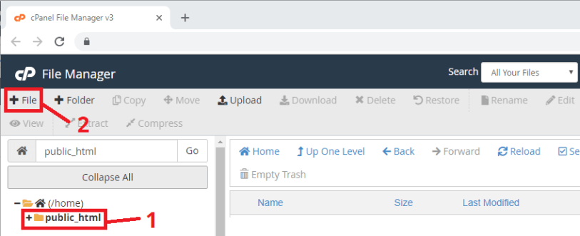

Create a new file in **/public_html** with this exact name and extension: *post-data.php*

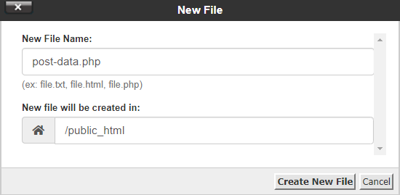

Creating PHP Script to Insert Values into Database

* First we will connect to our database (Open notepad and start writing these codes).
* Save it as **insert-db.php** and upload to the public folder of your hosting account.
* Now find the actuall url for this php script.
* In my case the url is **http://simplifiedcoding.16mb.com/insert-db.php**

<?php

define('HOST','mysql.hostinger.in');

define('USER','u813815354_user');

define('PASS','bhaq2010');

define('DB','u813815354_db');

$con = mysqli_connect(HOST,USER,PASS,DB);

$name = $_POST['name'];

$address = $_POST['address'];

$sql = "insert into Persons (name,address) values ('$name','$address')";

if(mysqli_query($con,$sql)){

echo 'success';

}

else{

echo 'failure';

}

mysqli_close($con);

?>

Insert data

<http://simplifiedcoding.16mb.com/insert-db.php>?name=tomas&adress=Mexico

Creating PHP Script to Search

<?php

define('HOST','mysql.hostinger.in');

define('USER','u813815354_user');

define('PASS','bhaq2010');

define('DB','u813815354_db');

$con = mysqli_connect(HOST,USER,PASS,DB);

if (mysqli_connect_errno($con)) {

echo "Failed to connect to MySQL:". mysqli_connect_error();

}

$nombre = $_POST['name'];

$result = mysqli_query($con,"SELECT address from Persons where name='$nombre'");

$row = mysqli_fetch_array($result);

$data = $row[0];

if($data){

echo $data;

}

mysqli_close($con);

?>

Search

http://myweb.hostei.com/search.php?username=tomas